1. Admin login button should not be available for general users
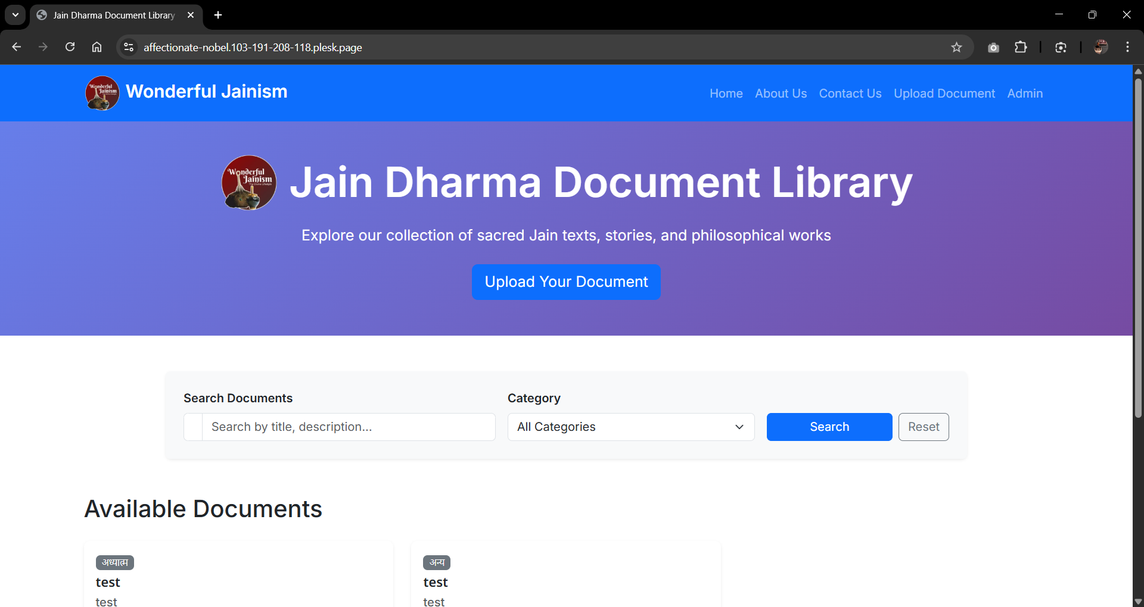
2. View/Upload Documents button not visible in Edge Browser
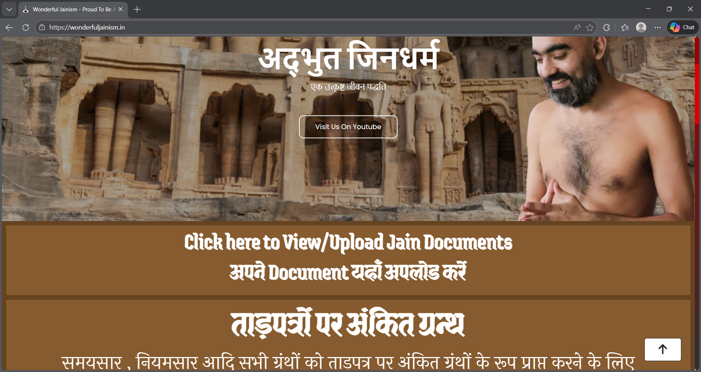

3. View Online button showing document in unknown language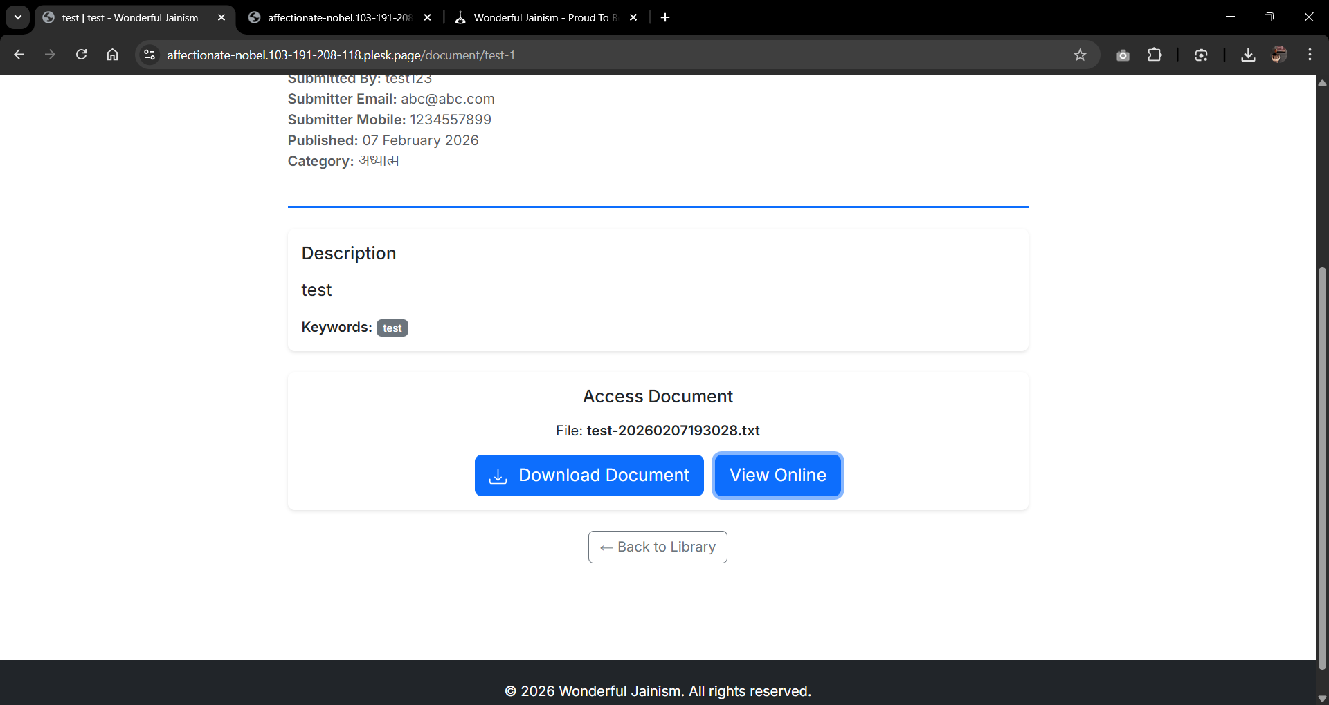 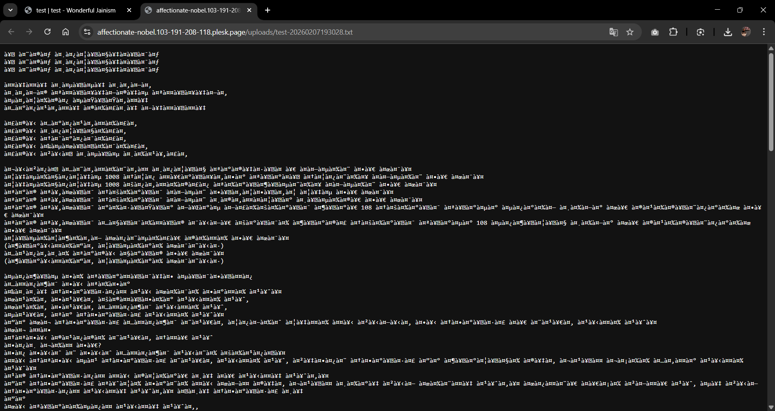

4. View/Upload Documents button not visible after reload in Chrome(Inconsistant)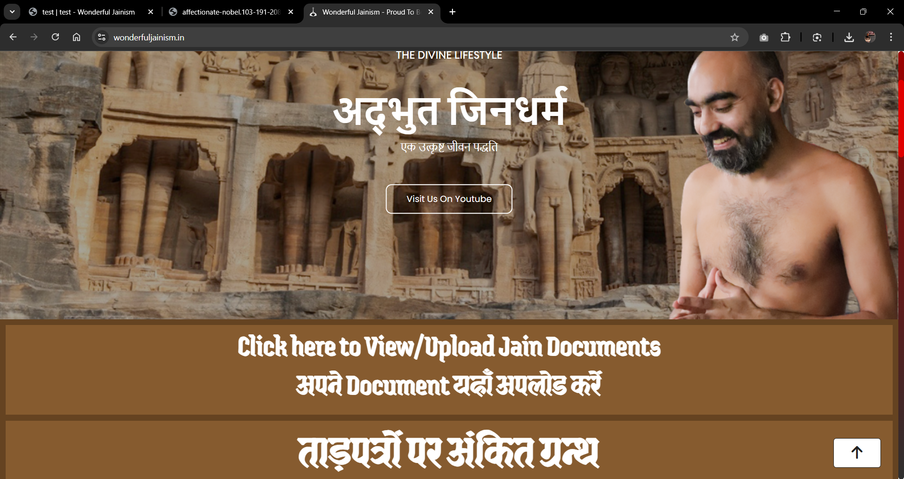

5. Edit document not working (Is there any limitations/prerequisites?)